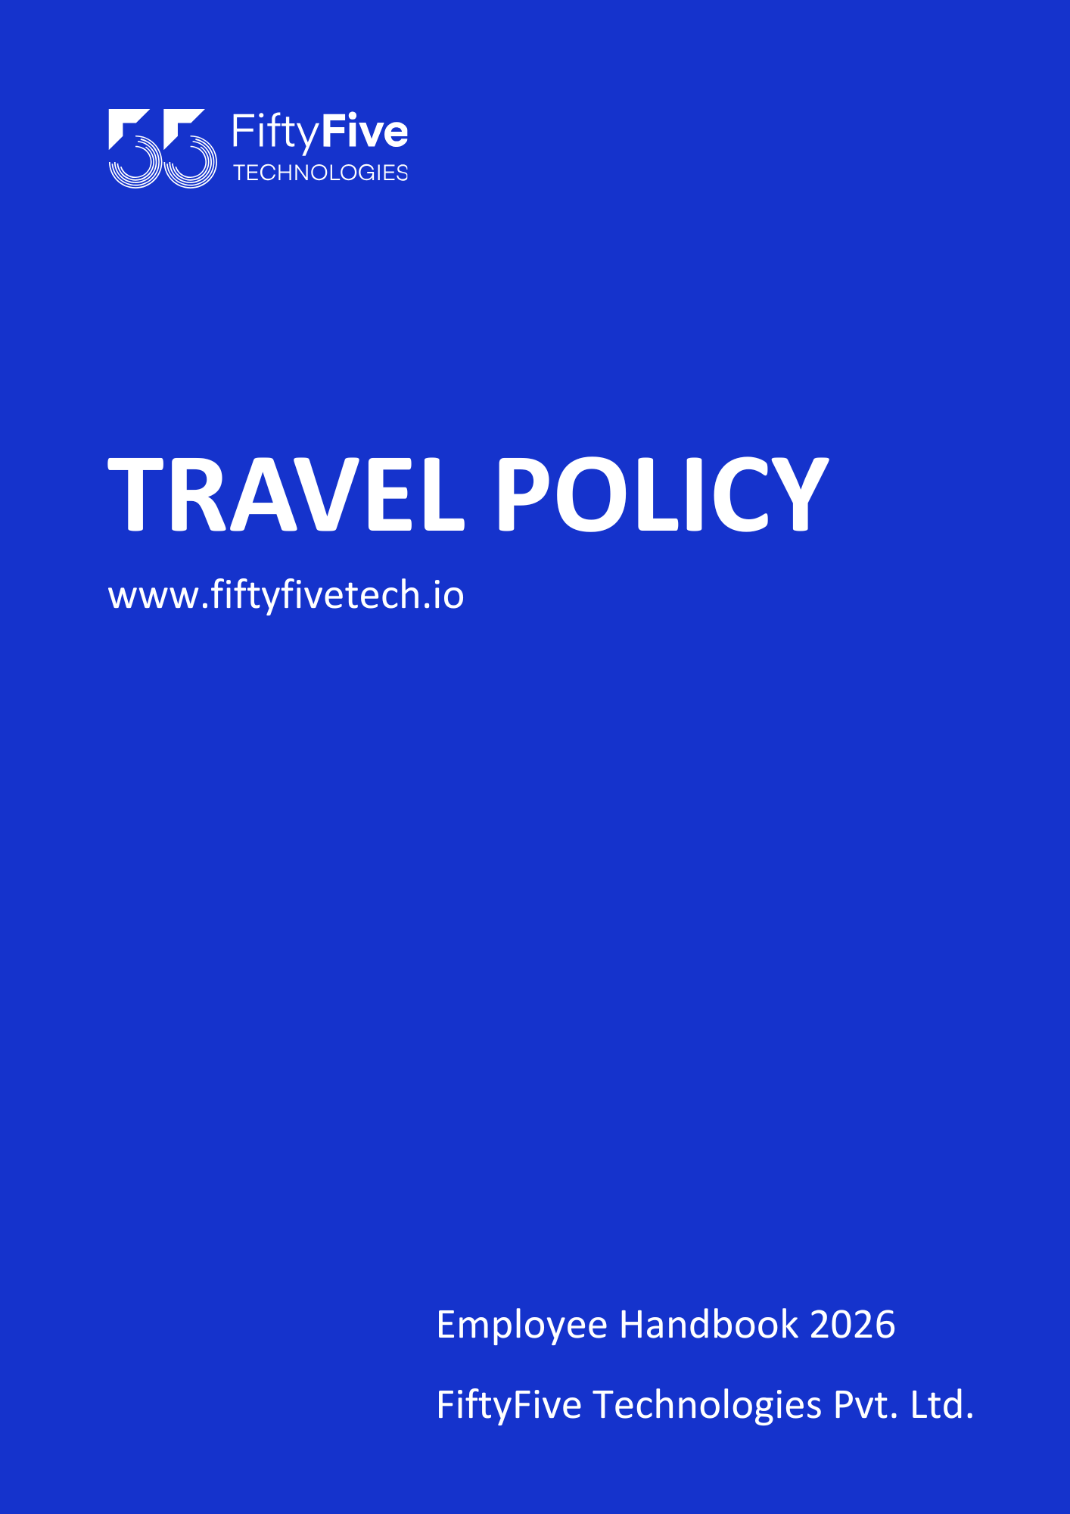
Tra

Travel Policy

Document Release Notice

This FiftyFive Technologies Policy on travel and entertainment policy is released for use in FiftyFive Technologies Pvt Limited with effect from 01 January 2026.

This document is subject to FiftyFive Technologies Pvt Limited Procedure and subject to change at anytime as per the company policy.

Approved By: Jyothi Sharma (CEO-FiftyFive Technologies Pvt. Limited)
Approved By: Sanchi Saxena (Head HR-FiftyFive Technologies Pvt Limited)

TRAVEL POLICY
Purpose
This document provides guidelines and establishes procedures for employees incurring business travel and entertainment expenses on the company’s behalf.

Objective
- To ensure all employees have a clear and consistent understanding of policies and procedures for business travel and entertainment.
- To provide business travelers with a reasonable level of service and comfort at the most cost- effective level.
- To maximize the company’s ability to negotiate discounted rates with preferred suppliers and reduce travel expenses.

Scope
This travel policy applies to all employees of FiftyFive Technologies Pvt Ltd and all those traveling on behalf of FiftyFive Technologies Pvt Ltd.
- Responsibility and Applicability
The traveler is responsible for complying with the travel policy. The approver is responsible for accurately reviewing expense reports for compliance.
  - The company will reimburse employees for all reasonable and necessary expenses while traveling on authorized company business.
  - The travel should be approved and informed to the HR department prior to at least one month.
  - The company assumes no obligation to reimburse employees for expenses that are not in compliance with this policy. Travelers who do not comply with this travel policy may be subject to:
- Delay or withholding of reimbursement
- Disciplinary action
- This Policy is applicable to all employees who are traveling in terms of business purpose only on behalf of the requirement claimed by the company.

- Who to Call on Travel Policy Issues:
Any questions, concerns or suggestions regarding this travel policy may be directed to the HR department of FiftyFive Technologies Pvt Ltd.

General Guidelines to be followed in the policy:
- A travel request must be approved before proceeding on any international or domestic travel.
- Any international or domestic travel request must be raised and followed as per the company travel policy and procedure.
- If there is any change in the travel (domestic or international) due to any reason and it is more costly than the approval that has already been taken, a fresh travel request needs to be raised in this case.
- Any employee who requires traveling for business purposes must get approval in advance from the reporting manager and the head of the human resources department.
- An email needs to be sent to the finance and human resource department along with approval mail to get the travel advance.
- Most economical modes of travel and fastest route to the destination would be reimbursed.
- Food expenses are allowed only as per the limit of entitlements.
- No expense will be reimbursed for alcoholic beverages or cigarettes etc.
- The expense report with travel requests submitted to the finance department must consist of the original boarding pass and travel -tickets. Any deviation from the tour program shall be approved by the reporting manager and the head of the human resources department.

Traveling By Air:
Employees are expected to take the lowest airfare and fastest route to the destination while traveling. The undermentioned guidelines to be followed while traveling by air for the company's business purpose.
- There should not be more than 1 stoppage in case of domestic travel.
- As per the Company travel policy any exception needs to have approval from the reporting manager and the head of human resources department.
- Any kind of additional fee which is occurring due to any reason like seat upgradation etc. will not be included.
- All ticket bookings need to be initiated by the Human Resources Department and shall be approved prior to the bookings from the Finance Department.

- Class to be Chosen
  - While on air travel, organization employees are expected to fly in the economy class which comes under the category of economical fare. Business class is allowed only for management level and above.
  - All policy exceptions must be noted on the travel request form and must be approved in advance by the management and above level.
  - In case any rebooking is done, it must be reimbursed in case of emergency only.

- Cancellation of Traveling:
In case of any cancellation done to the already planned business trip, the employee must inform the travel help desk who in turn will check from the carrier if the ticket can be refunded.

Rail Transportation
    - Rail transportation can be availed by the employee in case travel distance is less than 12 hours.
    - Rail transportation must be done in the most economical way and with the fastest route of travel only with prior approval from the reporting manager and the head of the Human Resources Department.
    - Bookings need to be initiated by the Human Resources Department only with prior approval to the Finance Department.

Lodging
Using the “Corporate travel policy " the organization has tie-ups with different hotels.
  - The bookings will be taken care strictly by the HR team and the details will be shared accordingly to the respective employee official mail ID.
  - Any exception in terms of hotel stay must be approved by the reporting manager and the Head of Human Resources department. before the start of travel.
  - In case of non-compliance with the travel policy, the extra amount paid will be bearable by the employee.

Reimbursement of Meal and Conveyance Expense
The reimbursement of the travel expense will be done on the basis of below mentioned points:
- Meals Expenses:
The company policy states that expenditure incurred on meals (breakfast, lunch or dinner) will be reimbursed while the employee is on business travel up to INR 700 per person in a day.
- Cabs Expenses:
  - The company policy states that expenditure incurred on travel from the destined hotel to office location in Jaipur/Gurgaon/Indore will be reimbursed while the employee is on business travel upto INR 200 per person in a day.

The process to raise travel request:
- The process to be followed by an employee while going on domestic travel as per travel policy template is explained below.
- If any team is planning to travel for the business requirements, The Travel Request Form needs to be filled out promptly. To streamline the process, the Reporting Manager (RM) will fill out the Travel Form on behalf of the entire team & will get signed by the HR Manager.
- It is mandatory for employees traveling for official purposes to complete the Travel Request Form . The form must be filled out by the employee and signed by both the Reporting Manager & HR Manager before the trip is undertaken .
- Employees have to submit the actual bills in KEKA however if any changes are highlighted separately.

TRAVEL PROCESS FLOWCHART
Travel Plan before 15 days
Approval should be done prior 15 days by Filling Travel Request Form
Travel form gets signed by RM and HR

PROVISIONS (what is not included in travel policy):
- Gatherings or outings organized spontaneously by team members for team-building purposes may not fall under the official travel policy.
- Travel for personal events such as weddings, family reunions, or other non-business events will not be covered under the Travel Policy.
- If any team, along with the Reporting Manager, requires employees to report to the office for a specific duration to fulfill team requirements will not be covered under the travel policy . Such instances fall outside the scope of travel reimbursement of allowances.

Right to Amend Policies
This Employee Handbook is intended to provide general guidance on Company policies and practices. FiftyFive Technologies reserves the right to amend, modify, suspend, or withdraw any policy, procedure, or benefit described in this handbook at any time, with or without notice, based on business, operational, or legal requirements.


